Proof of Concept Documentation

Introduction
This work presents a real-time voice chatbot system designed for noisy environments and multilingual (Hindi/Hinglish) interaction, based on a 3-layer architecture.
The goal was to:
- Maintain low-latency noise suppression (<200 ms)
- Ensure cost efficiency
- Build robust speech detection
- Enable safe interaction via validation logic

Research-Based Conclusion of the 3-Layer Architecture:
1. Findings from Noise Reduction Research
From analysis of:
- RNNoise (GRU-based real-time denoising)
- DeepFilterNet, DNS Challenge papers
- Real-time DSP constraints (STFT, frame processing)
Concluded:
- Real-time noise suppression requires frame-based processing (10–20 ms)
- Cloud-based suppression introduces network + buffering latency
- Low-latency models like RNNoise are suitable for edge execution
Conclusion:
- Noise suppression must be handled at the User Side (Edge Layer) to meet <200 ms constraints.

2. Findings from Speech Recognition Systems
From studying:
- Azure Speech SDK
- Google Speech-to-Text
- Whisper, NVIDIA Riva
Founded:
- ASR models require high compute and scalability
- Cloud systems provide:
  - multilingual support
  - streaming inference
  - model updates
Conclusion:
Speech recognition and language understanding must reside in the Cloud Layer.
3. Findings from Indian Linguistic Conditions
From analysis of:
- AI4Bharat Indic ASR
- Hinglish/code-switching behavior
Founded:
- Mixed-language inputs reduce ASR confidence.
- Noise + code-switching increases ambiguity.
Conclusion:
A post-processing control layer is required to verify output before execution.
5. Findings from Cost and Latency Analysis
From evaluating:
- Cloud pricing models (Azure Speech, OpenAI)
- Streaming vs filtered audio
Observed:
- Sending raw audio increases:
  - bandwidth
  - compute cost
- Silence/noise contributes no value
Conclusion:
Preprocessing (VAD + denoising) must be done at User Side to reduce cost.

6. Findings from Real-Time Constraints
From latency breakdown:
- Frame processing: 10 ms
- RNNoise: ~1 ms/frame
- Network + ASR: dominant latency
Concluded:
- Only lightweight operations can run on edge.
- Heavy models must remain in cloud.

Derived Architecture from findings:
User Side → Cloud Side → Developer Side
(Noise + VAD) (ASR + AI) (Control + Safety)
Through analysis of real-time noise suppression techniques, speech recognition systems, linguistic challenges, and cost-latency trade-offs, I have derived a 3-layer architecture where edge processing handles noise and filtering, cloud systems handle speech understanding, and a developer-controlled layer ensures safe and reliable execution.

Architecture Diagram:
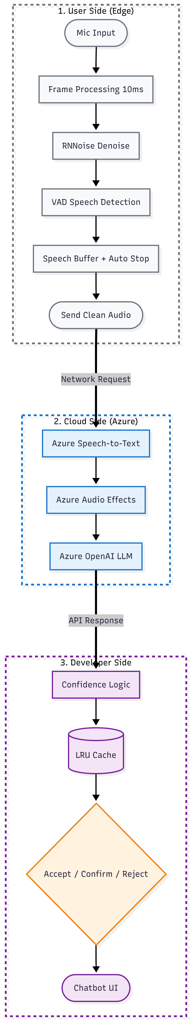
From the above Idea I have developed a prototype as a demonstration for POC, I have integrated the Gemini API Key in the cloud side as this is just a prototype.
The architecture I have followed for developing this POC is:
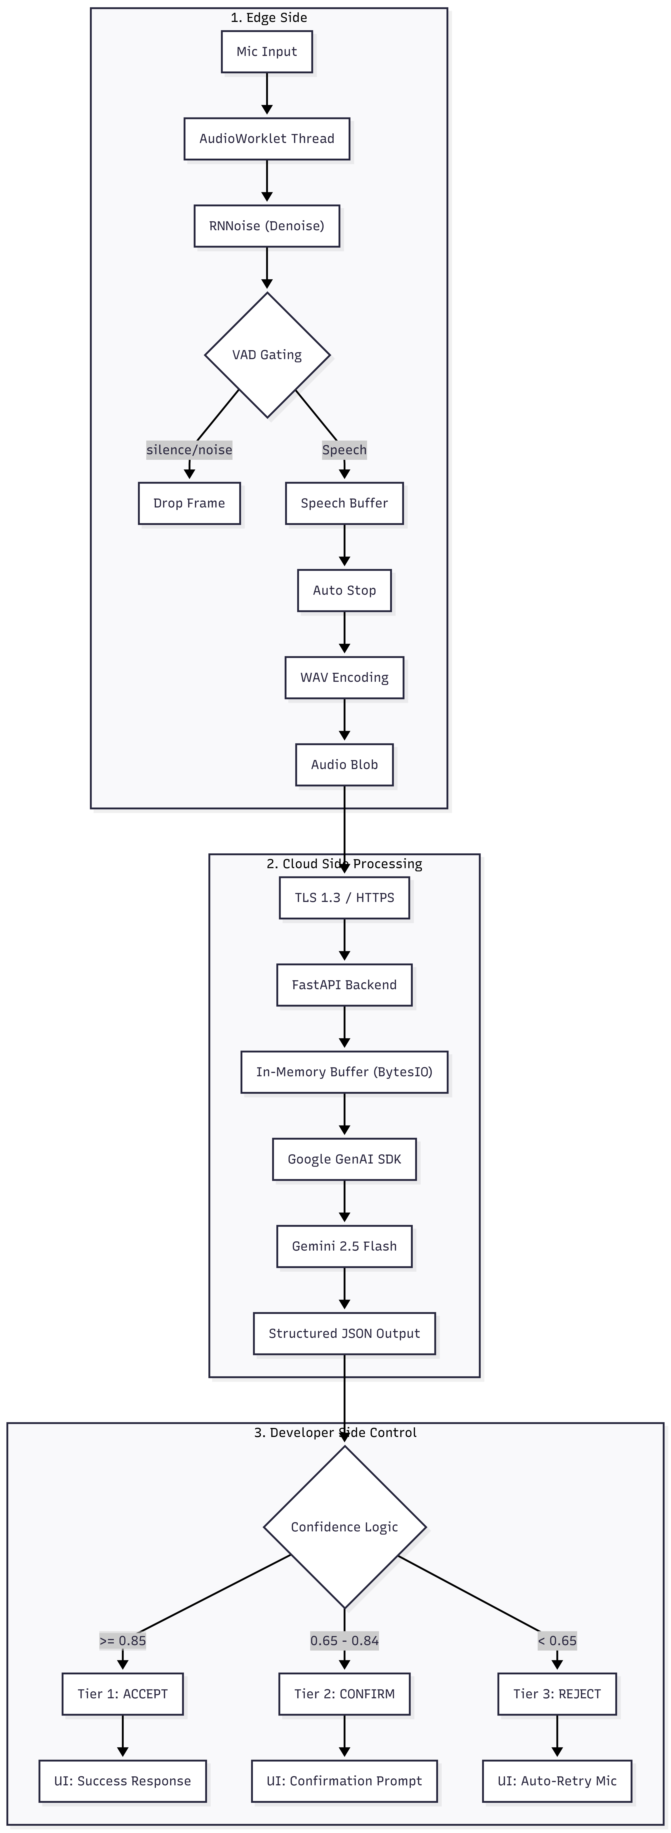
For the prototype, I integrated the Gemini API in the cloud layer; any cloud service can be used for the final build.
VaakBot Voice System — Documentation for the Codebase
Brief Overview:
This document explains the new implementation of VaakBot: a real-time voice chatbot pipeline that processes Hindi/Hinglish audio, suppresses background noise on the edge, sends only speech-worthy audio to the backend, and returns a structured AI response with confidence-based UI handling.
The system keeps the same 3-layer architecture we designed originally:
- User Side (Edge) — microphone capture, frame processing, RNNoise denoising, VAD gating, speech buffering, auto-stop.
- Cloud Side — FastAPI backend, in-memory audio handling, Gemini-based audio understanding, structured JSON response.
- Developer Side — confidence thresholds, ACCEPT / CONFIRM / REJECT decision logic, and chatbot UI handling.
Original Idea vs. Current Implementation:
Original 3-layer architecture:
- User Side: capture audio and prepare it for processing.
- Cloud Side (original design): Azure Speech / Azure Audio Effects / Azure OpenAI.
- Developer Side: validation, confidence checks, and safe execution.
Current implementation:
The cloud layer in the current prototype was implemented using Google GenAI + Gemini 2.5 Flash as the working backend, while preserving the same architecture and logic flow.
The important point is that the architecture did not change; only the cloud service provider used for the prototype changed.
The new frontend is a full conversational UI with a real-time audio pipeline.

User Interface:
The UI contains:
- a chatbot header,
- a mic button to start/stop recording,
- a waveform canvas,
- a live VAD indicator,
- a silence auto-stop bar,
- a response card showing transcript, confidence, and verdict,
- latency metrics and logs.
Audio Capture Layer:
The code captures audio using the browser microphone and an AudioWorklet thread. AudioWorklet is the correct choice for real-time audio because it runs in a low-latency audio processing thread rather than on the main UI thread.
RNNoise Denoising:
The frontend uses RNNoise WASM for noise suppression. RNNoise is a lightweight GRU-based denoiser designed for real-time speech enhancement.
The code loads RNNoise from WebAssembly, initializes the state, and processes audio frame-by-frame.
Frame Size and Timing
The frontend is configured for:
- Sample rate: 48,000 Hz
- Frame size: 480 samples
- Frame duration:
$$\text{Frame Duration}=\frac{480}{48000}=0.01\text{ s}=10\text{ ms}$$
So the system processes audio in 10 ms frames.
VAD Gating
The system uses a VAD decision based on RNNoise output probability.
- If the frame is speech-like, it is kept.
- If it is silence/noise-like, it is dropped.
This reduces unnecessary cloud traffic and lowers cost.
Speech-Based Auto Stop
The recording does not stop on pure silence alone. It stops when there is no speech for a fixed duration, even if background noise is still present.
In the current implementation:
- SILENCE_FRAMES_MAX = 200
- each frame = 10 ms
So:
$$200×10\text{ ms}=2000\text{ ms}=2\text{ seconds}$$
The recording stops if there is no speech for 2 seconds.
WAV Encoding and Upload
Before sending audio to the backend, the frontend:
- merges buffered frames,
- converts Float32 samples to PCM 16-bit,
- creates a WAV blob,
- uploads it to the backend using fetch().
What this frontend proves
This file proves that the core edge logic works:
- real-time frame processing,
- denoising,
- speech filtering,
- speech-based stopping,
- browser UI updates,
- backend-ready WAV packaging.
The backend is implemented in FastAPI and uses the Google GenAI SDK.
Backend responsibilities
The backend:
- receives uploaded audio,
- validates or re-encodes it as WAV,
- places audio in memory,
- sends it to Gemini,
- receives structured output,
- calculates confidence-based verdicts,
- returns a JSON response to the UI.
In-Memory Processing
The backend uses:
- io.BytesIO()
- wave.open(..., 'wb')
This means the audio is processed in RAM, not written to disk.
This improves speed and keeps the request temporarily adding a layer for security advantage as the data is never written to the persistent storage.
Structured Output
The backend defines a response schema:
- transcript
- confidence_score
- ui_confirm
- ui_reject
This is important because the model response is not free-form text; it is constrained into a predictable JSON-like structure.
Confidence Logic:
The backend maps confidence into a verdict:
- ACCEPT if the score is high,
- CONFIRM for medium confidence,
- REJECT for low confidence.
This supports safe conversational control.
Audio Normalization:
The backend enforces a consistent WAV format in memory. This avoids format mismatches and keeps the pipeline stable.
What this backend proves:
This file proves that the cloud side is able to:
- accept audio,
- process it in memory,
- obtain structured AI output,
- apply a decision policy,
- send back UI-ready results.
Audio and Latency Calculations:
Frame duration:
Using 48 kHz audio and 480 samples per frame:
$$\text{Frame Duration}=\frac{480}{48000}=10\text{ ms}$$
Speech validation window:
The code waits for 30 consecutive speech frames before it considers speech to be stable:
$30×10\text{ ms}=300\text{ ms}$
This helps avoid false positives from short noise bursts.
No-speech stop window:
The recording stops after 200 no-speech frames:
$200×10\text{ ms}=2000\text{ ms}=2\text{ s}$

RNNoise latency:
The frontend measures RNNoise processing time per frame and accumulates it. The expected denoising time is approximately ~1 ms per frame in the browser-sized POC.
Data reduction from VAD:
Because only speech frames are buffered and sent, the cloud receives much less useless audio. If speech occupies about 40% of the stream, then about 60% of the traffic is reduced.
Future Integrations:
Silero VAD: Silero VAD is a strong future upgrade for speech detection.
Safe sources:
- https://github.com/snakers4/silero-vad
- https://pytorch.org/hub/snakers4_silero-vad_vad/
It can be integrated later if a separate neural VAD model is required instead of using RNNoise-derived gating.
LRU Cache: An LRU cache can be added in the developer layer for repeated high-confidence queries.
Concept:
- if the confidence is extremely high,
- and the query matches with the cached intent,
- then the response can be returned without going back to the cloud.
This would reduce:
- latency,
- cloud usage,
- token cost.
This cache is a future optimization idea and is not part of the current code.

What Is Implemented Now vs. What Is Future Work:
Implemented now:
- real-time audio capture,
- AudioWorklet processing,
- RNNoise WASM denoising,
- speech/noise gating,
- no-speech auto stop,
- WAV generation,
- FastAPI backend,
- in-memory audio handling,
- Gemini structured output,
- confidence-based response logic,
- chatbot UI response handling.
Future work:
- Silero VAD integration,
- LRU cache optimization,
- Azure cloud deployment,
- deeper metrics logging,
- production-scale observability.
Conclusion:
This codebase correctly implements the core 3-layer idea in a working form:
- User Side: real-time edge noise suppression and speech gating,
- Cloud Side: in-memory AI processing and structured transcript output,
- Developer Side: confidence-based safe decision handling.
The current implementation is a strong technical proof of the architecture, and the planned future integrations (Silero VAD and LRU cache) fit naturally into the same design.
Short Summary:
This codebase demonstrates a practical real-time voice chatbot pipeline with low-latency edge audio processing, structured cloud inference, and safe developer-layer control.
(End of Documentation)

